# Mid - iCIMS Hiring Manager User Guide

# Login

* To log into the iCIMS system click the grey and blue button at the bottom of the **Jobs at Mid** page on Mid’s website
* The password is synced with your Mid sign-on. Login to the portal and you will be directed to the iCIMS home page

# Creating Requisitions (for Directors/Deans/Hiring Managers)

* Hiring Manager = HM
* After hiring manager (HM) and Director, Dean, AVP or VP have agreed on the need for a position, the HM updates the job description and sends the WORD version to HR.
* HR will create/update the job template in iCIMS and notify HM when ready.
* HM creates the job requisition.
* To create a new **Requisition** and route for approval:
  + Click *Create* on the main menu.
  + Click *Job* from the dropdown menu (Create New Job template will appear)
  + Start typing the Job Title and select the appropriate job title from the *Template* list.



* + Complete all required fields. Any justification or additional information can be entered in the *Notes* section (the notes are NOT displayed on the job posting). Click the *Next* button at the top.
  + Review the job description. If there are no changes needed, click the *Finish* button. If the job description requires editing or no job description is included, please contact Human Resources (HR) with the changes.
  + Once you click *Finish*, a job approval pop-up box will appear.
  + Complete the Approval List as follows:
    - In the Add Approver section, click *Make a Selection* drop-down and select Approvers names/email. You will want to include:

1. Your supervisor and/or AVP/VP as the first approver
2. Associate VP of Human Resources – Lori Fassett as next approver
3. Select Dawn Tanner as last approver so that Dawn is notified when job is approved
   * + Click the *Save & Begin Approval* button.



* + An email will be sent to the first approver on the approval list. The HM will receive an email notifying them of the approval or denial of the requisition. The submitter can also monitor which approver has the request at any given time.
  + HM will see the job in *My Pending Jobs* until approval, and in *My Open Jobs* after approval.

# Viewing Requisitions

* To view ***pending r*equisitions** and the approval status:
  + Select My *Pending Jobs* in the *Jobs* panel at the right side of the Dashboard.
* To view **current** requisitions:
* Select the link under *My Open Jobs* in the *Jobs* panel at the right side of the Dashboard.

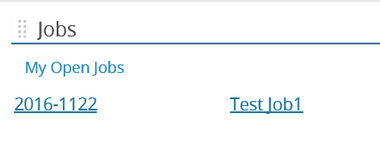

# Reviewing candidates

* You will NOT receive an email notice when candidates have applied to the position. You will need to log in to iCIMS to review candidates periodically or after the job posting ends.
* Candidates will be sorted into bins based on their status (i.e., New Submissions, Reviewed, Scheduled for Interview, etc.).
* To view candidate weighting while viewing the candidates from the People tab, click on the *Screening Questions* icon (?) to the right of the candidate’s name.

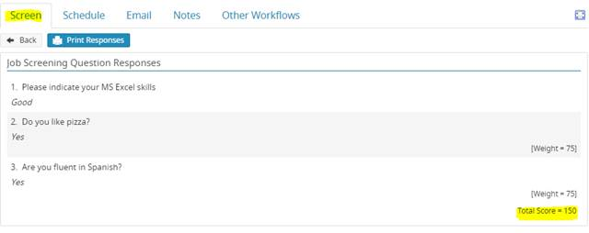

* To view a candidate’s profile, click on the candidate’s name. Their resume will be displayed.
* To view the candidate’s cover letter and other documentation, click on the *Candidate Details* tab. The cover letter will be in the *General Information* section.

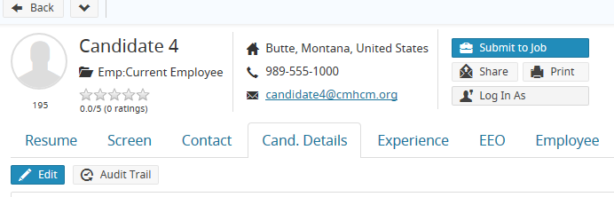

* *Person Screening Questions* and *Job Screening Questions* answers can be viewed on the right, under the *Screen* tab (Screen tab may be under the “More” tab).
* Candidates can also be viewed by accessing the job and clicking on the arrows under the *People* tab.

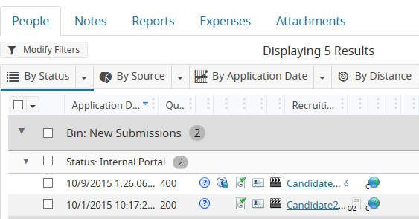

# Updating Candidate’s Status

* Once candidates are reviewed, you will ***Advance*** the candidate by selecting *Reviewed: Selected for Interview.* ***Reject*** candidates not selected by selecting *Reviewed: Not Selected.* Select up to six candidates to be interviewed per vacant position.

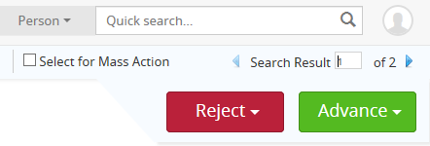

# Selecting Candidates for Interview

* **HM** will notify Human Resources via email when all candidates have been reviewed. HR will review the candidates selected and notify HM of any concerns.
* **HM** should allow interviews for qualified internal candidates whenever possible (discuss with HR if you are not sure whether or not to include an internal candidate).
* **HR** will schedule interviews with those candidates that have p*assed HR review*.
  + HR will need to know the date and alternate date of interviews, the campus and room, the amount of time needed for each interview, and the interview team members.
  + For Hourly positions: a skills/aptitude assessment will be provided to each candidate. These will generally take place immediately following the team interview and will take about 30 minutes per candidate. With enough notice to HR, the assessments may take place prior to interviews.
* HR will email candidates to confirm interview date/time using the email template within iCIMS.

# Preparing for Interviews

* If the interview team members are provided to HR, HR will load their names in iCIMS and each member will be able to view all candidates for that job posting.

However, if you wish to forward the candidate’s resume to the interview team via email, click on the *candidate’s name* from the bin. When the resume is displayed, click the *Share* button near the top of the page. An email template box will pop-up with the default email template. Add the names of your interview team members in the *To* box and click *Send.*

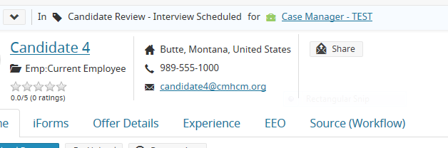

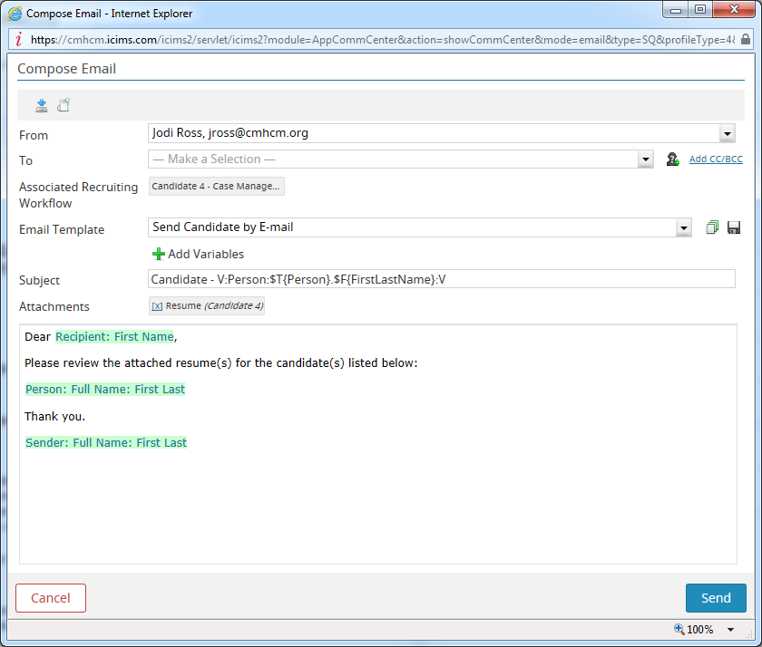

* **Interview questions** - You will want to prepare these in advance. HR will assist you with providing previous question sets if available and/or reviewing new questions you prepare. HR can also, upon request, provide question suggestions. Human Resources will review new or revised questions for appropriateness and offer suggestions if needed.  This will also allow HR to keep them on file for future interviews.
* Interview preparation resources are also available on the HR webpage on the Hiring Manager/iCIMS tab.
* If not already determined, seek individuals to participate on the interview committee.
  + The committee should include diversity of individuals (i.e., male/female, backgrounds, beliefs, etc.).
  + Interview committees for full-time positions should consist 3-5 members.
  + Interview committees for part-time and student position should include 2-3 members.
* After interviews are complete, **HM** forwards all completed interview sets for **all** candidates to HR. HR will keep vacancy and interview materials on file in accordance with the retention policy.

# Selecting the Candidate

* **For the top candidate**, ***Advance***the candidate to *Decision Pending/Checking References.*
* ***Conduct* professional references** including the candidate’s current supervisor when possible. (To access the reference check form, click the New Reference Form link on the HR webpage on the Hiring Manager/iCIMS tab. You can open and save the reference check form to your desktop.
* **Full-time Administrator candidates must meet with the President PRIOR TO any offer of employment is extended!**
* **Offer Approval**: Once the HM is ready to make an offer to the top candidate, **HM** will update the *Offer Details* tab of the selected candidate with the salary/pay rate requested for the candidate.
* **HM** will ***Advance*** candidate to *Launch Offer Approval:*

1. Add next level up manager from the dropdown menu.
2. For Full-time Hourly candidates, you must include the VP of your department.
3. Add Associate VP of Human Resources – [lfassett1@midmich.edu](mailto:lfassett1@midmich.edu) (Assoc VP of HR approval is not needed for Adjunct positions).
4. Click Save & Begin Approval. Select OK once prompted to send approval email.

# Approval

* Once the offer recommendation is approved, HM may proceed with the offer to the candidate.
* **HM** calls selected candidate with offer. Make offers contingent upon background check.
* Offers:
  + If the candidate accepts, ***Advance***candidate to *Offer Accepted.*
  + If candidate requests time to think about offer, request 24-hour decision by candidate and ***Advance*** candidate to *Offer Extended.*
* **HM informs HR** when candidate accepts. For full-time administrative and faculty positions, **HR** will send the candidate an offer confirmation letter and benefits summary (they will be instructed to contact HR with any benefit questions).
* **HM**: Call candidates interviewed, but not selected and inform them of the decision. It is best to keep your responses general and short. Example: Thank you for taking the time to interview with us, however, we have decided to go with another candidate. Inform HR once this is complete and HR will send formal thank you letters.

# Post Approval

* **HM**: When the candidate accepts the offer, submit New Hire/Change Form to HR.
* HR schedules onboarding such as new hire paperwork completion and orientation with candidate.
* HR will send “no thank you” letters to candidates not selected.

# Additional iCMIS Tips

* Click the *iCIMS logo* in the upper left corner to return to the iCIMS home page.
* Click on arrows to expand sections, such as Bins and Statuses for applicants, to view additional information.

*Updated: 10/12/21*