Kushner & Company, 2427 West Centre Avenue, Portage, MI 49024 800-KUSHNER or 269-342-1700, ext. 213, FSA@kushnerco.com

Welcome to the Mid Michigan Community College Benefits Newsletter!

Mid Michigan Community College
Employee Benefits Contents

In this newsletter you will find information related to the Mid Michigan Community College employee benefits program administered by Kushner & Company. The following pages will detail the benefits available to you, answer many of your general questions, and provide information on how to access your benefits. If you need additional information, or if you have questions about your account, you may always contact your Human Resources department or Kushner & Company (contact information below).

Kushner & Company 2427 West Centre Avenue
Portage, MI 49024
800-KUSHNER or 269-342-1700, ext. 213
FSA@kushnerco.com
Online Account Access: http://www.mywealthcareonline.com/Kushner (instructions to follow)

Pre-Tax Benefits = YOU WIN BIG!!

All of the benefits described in this newsletter are provided to you on a pre-tax basis. That means no federal, state, or local income tax, and no FICA deductions! Without the advantages that these benefits provide, the expenses that you incur would be subject to the same taxes as your paycheck. Because your employer has taken the necessary steps to implement these plans on your behalf, the benefits you receive are not taxable income to you! All of this adds up to a big WIN for you and your family – saving you approximately 30% in taxes on benefit expenses!

Introduction

Flexible Spending Accounts HSA Benefit
Submitting a Claim

Online Access Instructions

Direct Deposit of Reimbursements

Flexible Spending Accounts
Flexible Spending Accounts

The IRS allows your employer to provide you access to two money-saving, tax-favored vehicles to save money on things you already pay for. The two accounts are the Health FSA and Dependent Care Reimbursement Account. Prior to the beginning of each plan year, you estimate the amount of your anticipated expenses and decide how much of your pay you wish to contribute to the Health FSA or Dependent Care Reimbursement Account. Very simply, you have deductions taken in equal installments each payroll into the account available for your use. Your taxable income is reduced by the amount you elect to deposit into this account. Your state, federal and social security taxes are reduced accordingly.

Contributions to your account will stop at the end of each year and will not continue unless you elect to participate in the new year. Your participation in the plan will also end at the time you terminate your employment. Remember too that any balance you have at the end of the plan year must be forfeited by law. Plan conservatively so you don’t run into the use-it-or-
lose-it rule!

Dependent Care Account

Health Flexible Spending Account (FSA)

The Health FSA allows you to reimburse yourself for eligible, medically necessary expenses which are either not covered or are not reimbursed by any other source, up to the annual maximum. Because of the unknown nature of when you might need medical care, your balance is available to you from the first day of the plan year, and you pay the account back through the year with payroll deductions.

The Health FSA is available for you to reimburse the expenses of all members of your tax family. This means that even if you don’t cover your spouse or kids under your employer’s health plan, their eligible medical expenses are still reimbursable under the Health FSA.

The IRS defines an eligible expense as those incurred “primarily for the diagnosis, cure, mitigation, treatment, or prevention of disease or illness, or for the purpose of affecting any structure or function of the human body”. To help in interpreting this definition, we provide a detailed list
of common eligible expenses at
http://www.mywealthcareonline.com/Kushner. Some of the highlights include office visit or prescription drug copays, deductible or coinsurance expenses, glasses or contact lenses (non-cosmetic), dental expenses (non-cosmetic), orthodontia, and over-the-counter drugs and medicine (with a doctor’s prescription).
Worksheets and additional information on eligible items are available on http://www.mywealthcareonline.com/Kushner. How to submit a claim is detailed later in this newsletter.

If you contribute to a Health Savings Account (H.S.A.): You may not enroll in a regular Health FSA. You can however, enroll in a Limited Purpose Health FSA. A Limited Purpose Health FSA works exactly like a regular Health FSA except you are only eligible to be reimbursed for dental and vision expenses. All other medical expenses can be reimbursed from the H.S.A.

The Dependent Care Reimbursement Account allows you to reimburse yourself for eligible day care expenses that allow you and/or spouse to work. Anyone can be the provider of care as long as they are not another tax dependent and are willing to provide their Tax ID/SSN. The “care” cannot be tuition for schooling – the main purpose must be care, not education. Care can be for a tax dependent child or adult.

The maximum that can be elected is $5,000 per calendar year (or $2,500 if married filing separately). Unlike the Health FSA where the timing of expenses is not necessarily known, dependent care expenses typically occur on a pretty regular basis. Because of this, the amount available for reimbursement is equal to what is deducted each pay period.

How Much Can You Save?!

 | With Pre-Tax | After-Tax
Gross Salary | $28,000 | $28,000
Pre-Tax Expenses | $1,000 | $0
Taxable Salary | $27,000 | $28,000
Fed. Tax 28% | $7,565 | $7,848
FICA 7.65% | $2,065 | $2,142
State Tax 4.6% | $1,242 | $1,288
Net Income | $16,128 | $16,722
After-Tax Expenses | $0 | $1,000
Spendable Income | $16,128 | $15,722
Net Pay Raise | $406!

Details for your FSA plan:

Annual Health FSA Maximum: $2,550

Annual Run-Off Period: You will have a 90 day run-off period to submit expenses against the prior year’s balance.

Submitting a claim online: With Kushner & Company, you have the ability to enter a claim online at
http://www.mywealthcareonline.com/Kushner, and even scan and attach receipts right to that claim. Instructions for getting online are included later in this newsletter. To submit a claim:

- From the My Accounts tab select Submit Claims
- Click the add new button
- Complete the claim form (the fields marked with asterisks are required):
  - Select the benefit you want the expense to be reimbursed from (FSA, DCRA, HRA, etc)
  - Enter the date(s) the expense was incurred (not billed or
paid)
  - Enter the amount of the expense- the amount you are requesting reimbursement for
  - Enter the dependent name. If not in the drop-down, you can add a dependent from the My Info page and return to the claim to edit, or select N/A for employee.
  - Type the Provider name
  - Select the Provider Type (doctor, pharmacy, etc.)
  - If you have a receipt to attach to the claim, you may do so by selecting Browse and searching for the receipt. If you do not want to submit receipts online, select OK now
  - If you did select a receipt, select “Add file to list”
  - If needed, you may add a note to your claim in the Notes
section
  - When complete, click Ok.
  - Your newly-entered claim appears in the new claims box. If you have additional claims to enter, click the add new button again, and repeat the process until all claims are entered. Click the edit button to go back and edit anything you have entered on a claim, as needed. NOTE: Once you submit your claim, you are no longer able to edit it.
- When complete, acknowledge the certification text by checking the checkbox and click the submit button. A confirmation page displays, showing the tracking number and total amount for your submitted claim(s). Individual claim details appear under two headings; one for claims submitted with receipts, and one for claims submitted without.
- If you would prefer to fax in your receipts instead of
uploading them through the portal, click the view receipt submittal form button for a cover page that you can print and submit when faxing. It is important that you submit your receipt with the cover page included, as it contains specific information that speeds up the adjudication process. Without the cover page, your reimbursement may be delayed.

Submitting a Claim for Reimbursement

Kushner & Company provides a number of options for you to submit claims for reimbursement or processing. Included in your enrollment packet, and also available online at http://www.mywealthcareonline.com/Kushner, is a Request for Reimbursement Form. With the exception of online and mobile claims submission, this Request for Reimbursement Form must be completed and signed in order to receive a reimbursement from your account.
Submit Via Mail: To submit a claim via the mail, please
complete the Request for Reimbursement Form and include copies of all necessary receipts (see below for requirements). Mail them to:

Kushner & Company Attn: Your Employer 2427 W. Centre Avenue Portage, MI 49024
Submit Via Email: To submit a claim via email, please
complete the Request for Reimbursement Form and attached scanned copies of all necessary receipts and email them to fsa@kushnerco.com.
Submit Via Mobile App: To submit a claim via the
mobile application, download the “Kushner Participant Portal” app from your iOS or Android app store.
Local Drop-Off: If you are local, you can drop off your
Request for Reimbursement Form and necessary receipts in a 24 hour drop-box at the mailing address above.

“What is required to be on my documentation?”

Service Provider Name
- Date of Service (not necessarily date of payment)
- Expense Amount
- Service Incurred (office visit, dental cleaning, etc.)

Note: A credit/debit card receipt does not meet IRS standards.

Online Account Access

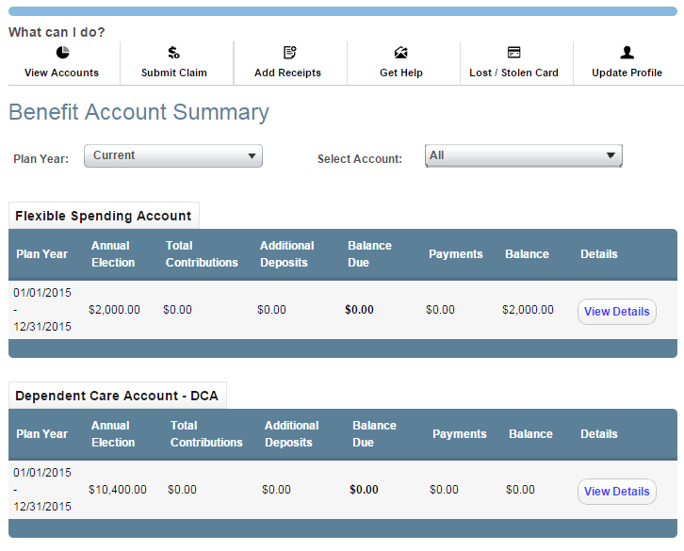

With Kushner & Company you can access your Flexible Spending Account (FSA) and/or HRA information at https://www.mywealthcareonline.com/Kushner. Information is available about your balance, payment information, account balance, personal information (such as address), eligible FSA expenses and other useful information, and online claim entry. Please take the time to familiarize yourself with all of the helpful tools on the website!

Registration
Step 1: If this is your first time accessing the portal, simply click the register button atop the right corner of the home screen.

Step 2: After clicking the register button, complete the registration form. Choose a username and password. Enter the required demographic information. Your employee ID is your Social Security number and your employer ID can be obtained from your account administrator. **If you already have a benefit debit card, the card number can be used in place of the employer ID in the registration ID field.

Before clicking register, be sure to view and accept the terms of use.

Step 3: After successfully completing the registration form, click register. The process may take several seconds. Do not click your browser’s back button or refresh the page.

Online Account Access
Continued

Secure authentication

The next part of the registration process involves setting up your secure authentication. This important step helps ensure your account is secure and private. After the registration form is successfully completed, you will be prompted to complete the secure authentication setup process. After reading the secure authentication setup instructions, simply click the begin step now button.

Step 1: Enter a personal phrase. This phrase can be anything easily identifiable to you, up to 40 characters long. Your personal phrase will always appear alongside your picture when you log in. You must also select a picture that gets linked to your personal phrase. During subsequent logins, viewing the combination of your personal phrase along with your picture are visual cues you are securely viewing the portal and can safely access your account.

Step 2: Select security questions. You must select four security questions and provide your secret answers. These questions are asked at random while you attempt to login to the portal. The questions help provide an additional layer of security and help ensure only you are able access your account

Step 3: Verify your email address. In the next page, you will be prompted to verify your email address. Enter your email address, and click continue setup. On the next page, you will be asked to verify all of the information you’ve entered during the secure authentication process. After you’ve reviewed and confirmed the accuracy of the information, please click submit setup information.

A confirmation page will display showing the registration process has been completed. At this point, you can either 1) sign off, or 2) proceed to your account.

Your first login

After registering, for all subsequent logins you can click the login link in the upper right corner of the home page. You will be prompted to enter your username, two of your four security questions, and finally your password.

Claims Reimbursement Direct Deposit Enrollment

The below form allows you to receive reimbursement of your claims directly deposited into the bank account of your choice. Once enrolled, you will remain enrolled from year-to-year. You do not need to complete if you are already enrolled. If you need to change your bank account information, you can do so at www.beneworld.com. Please complete and return this form to your employer or Kushner & Company.

Recordkeeper: Kushner & Company

Participant’s Employer:

I hereby authorize Kushner & Company, hereinafter called Recordkeeper, to initiate credit (deposits) transactions to my Checking Account indicated below at the depository financial institution named below, hereafter called Depository, and to credit the same to such account. I acknowledge that the origination of ACH transactions to my account must comply with the provisions of U.S. law. In addition, I agree to return any potential overpayment credit to my account to my employer in the form of a check. If you have previously enrolled in Direct Deposit you do not need to sign up each plan year.

Please provide with this agreement a sample voided check for your account.

Depository/Bank Name: Branch:

City/State/Zip Code:

Routing Number: Account Number:

This authorization is to remain in full force and effect until the Recordkeeper has received written notification from me of its termination in such time and in such manner as to afford the Recordkeeper and Depository a reasonable opportunity to act.

Name: Social Security Number:

Address:

Phone:

Date: Signature:

Return To: Kushner & Company
2427 West Centre Avenue Portage, MI 49024 fsa@kushnerco.com

